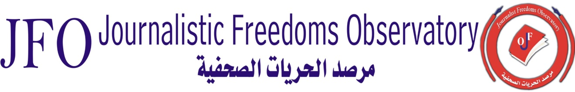

Indicators show that attacks on journalists are rising: 262 violations and attempts in one year.
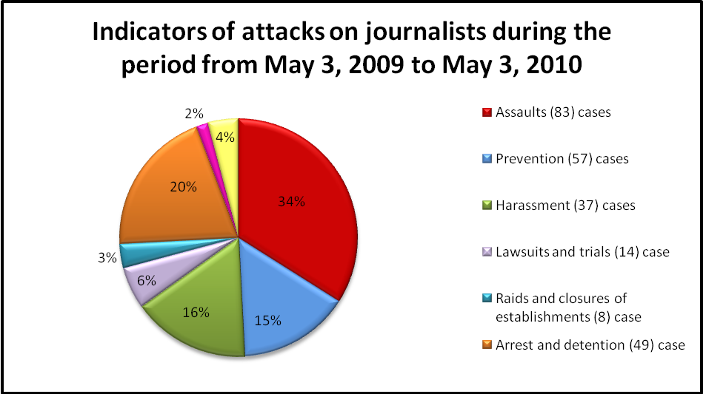
Violations against journalists and media organizations have been documented by the Journalistic Freedoms Observatory (JFO). The evidence shows that journalists are exposed to systematic harassment and violence, efforts by Iraqi government agencies and political entities to curb their press freedom and censor on-line and print publications, and impose regulations and restrictions on radio and television broadcasting. These measures also attempt to restrict journalists’ movement, by obliging them to obtain permits from military and security leaders in the field.

The National Communications and Media Commission (NCMC) has forced media organizations to sign and agree to a list of controlling regulations that are described by international organizations as new limitations and constraints. The unlimited power vested in the NCMC has given it the authority to halt media broadcasting and to shut down media institutions, as well as confiscate equipment, withdraw licenses, impose heavy fines, and provide lists of names of all personnel and equipment used. Similarly, attempts by the Ministry of Communications, the Baghdad Operations Command (BOC), and other official organizations to control Internet access and censor publications are considered a blow to media freedom in Iraq.
The number of incidents and violations committed against journalists between May 03, 2009 and May 03, 2010 was 262. Meanwhile, independent agencies and government ministries are doing their best to limit the free flow of information and to put pressure on field reporters to prevent them from doing their jobs.
Attacks against journalists can be categorized as follows:

- 83 cases of assault on reporters and cameramen by military and security forces
- 57 cases of harassment
- 39 cases of prevention and arrest
- 49 journalists detained for different periods of time
- 14 journalists and media organizations sued and taken to court
- 10 journalists escaped assassination
- 2 critically wounded
- 1 reporter kidnapped and assassinated
- 4 reporters kidnapped and then released after being tortured
Documentation shows that the most common weapons used by attackers are silencer guns and sticky bombs. Baghdadiya TV reporter Alaa Abdel Wahab, was killed in Mosul by a sticky bomb placed under the seat of his car on May 30, 2009. The same day, an al-Iraqiyah TV crew was targetted when a sticky bomb exploded in their technical support vehicle in the area of al-Adhamiyah. In that attack, broadcasting engineer Hameed Youssef Abdel was seriously injured and had to undergo two operations, while the sound technician and driver were also injured.
In Mosul, the most dangerous city for journalists, the correspondent of Salah Eddin TV Khaleda al-Mawla, survived an explosion by a sticky bomb placed inside her car. Al-Mawla said then that “This attack is absurd and one in a series targeting journalists in the city.” The Director of Relations at al-Rasheed TV was targeted by a sticky bomb placed inside his car on April 13 in Baghdad resulting in the amputation of his legs.
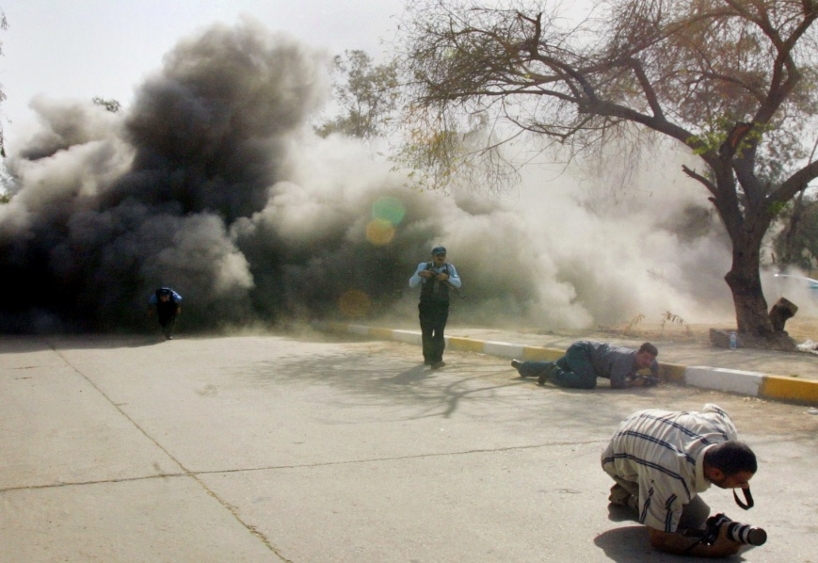
In November 24, 2009, journalist Imad al-Ebadi escaped an assassination attempt by gunmen who used silencer-fitted guns. He suffered serious injuries to hishead and neck. One of the bullets penetrated his neck while the other one got lodged in the right side of his skull. Al-Ebadi was driving his car when attacked by the gunmen in the Arasat area of central Baghdad. An independent journalist, al-Ebadi continued to criticize administrative and financial corruption in government, and he is one of the leading defenders of press freedom, transparency and the right of access to information.
Three reporters were seriously wounded during their coverage of the twin bombings that took place in downtown Karbala, including JFO representative Moataz al-Mashhadani, al-Forat TV cameraman Haidar Mohammed and al-Ahad TV cameraman Akram Abbas. Reporters covering the car bomb explosion on March 30 were seriously injured after a car bomb detonated and killed civilians at the scene.
Journalists and their support colleagues have been consistently targeted since the 2003 U.S.-led invasion: 247 Iraqi and foreign reporters have been killed (137 of those weres killed for their journalistic work), as well as 52 media technicians and assistants. Other indirect and unconfirmed n criminal activities have targeted journalists and media technicians, but not because of their journalistic work. 64 journalists and media assistants were kidnapped (most of them were later murdered) and 14 of them are still missing, according to JFO data.

Since 2003, Iraq has witnessed a rise of violence against journalists, while government pursuit to find the perpetrators has failed. There has been no success in the government’s investigation of crimes targeting journalists. Officials have either ignored the cases or recorded the instigators of the attacks as t “unknown.”

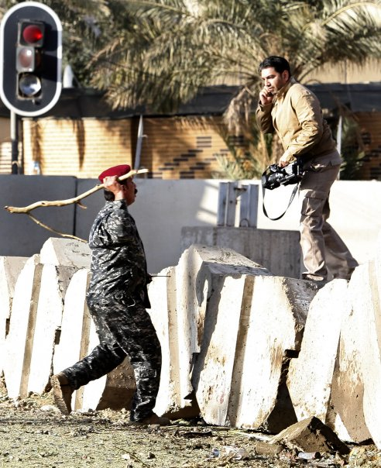
During the aforementioned seven year period, many journalists were harassed and beaten by Iraqi military and police on orders issued the Baghdad Operations Command and other security agencies. Military leaders appointed themselves as caretakers of journalists inside cities, and then obliged them to obtain approvals prior to covering any events. Even with advance approval, media teams were still blocked from practicing their work and in most cases were beaten. JFO has documented cases of attacks and harassment against journalists in several cities in Iraq, showing that security forces used force and intimidation, and destroyed recording and filming equipment to prevent journalists from doing their job. The following are some examples:
On January 24, 2010 Baghdad Operations Command personnel insulted and beat al-Baghdadiya TV reporter Ali al-Khalidi, in the al-Kahirah neighborhood north of Baghdad. They then broke his camera and detained him for a substantial period of time.

On November 4, 2009, the correspondent of Iraq Media Agency was severely beaten by members of the Iraqi army in the city of al-Mahmudiya. He was then transferred to the hospital for treatment where the medical report showed that he had been beaten with rifle butts.

On October 11, 2009, Anbar provincial police beat reporters and cameramen, broke a camera, confiscated videotapes and held two journalists inside the provincial building to prevent them from covering the news. The correspondent of Al-Sumaria TV Kamal Ayesh, confirmed to JFO: “We were attacked, beaten and insulted by members of the facilities guards and Anbar police.” The Beladi TV cameraman, Samir Fahad, whose camera was broken by a police officer, said that he and colleagues from other media outlets were beaten en masse as police tried to disperse and block them.

On September 14, 2009 eight reporters for al-Iraqiyah TV were severely beaten by security guards of the Baghdad Provincial Council.
On August 20, 2009 a security force in Baghdad arrested three cameramen working for international news agencies, and attacked four others when they were covering the the funeral processions of terrorist victims. A cameraman who was part of the team filming the incident said that the security force detained three of his colleagues: Thamir al-Sudani, the Reuters News Agency photographer; Reuters co-worker Haidar Kadhim Nour; and European Agency photographer Shehab Ahmed.

On December 12, 2009 the Iraqi army arrested Reuters News Agency photographerAhmed Malik, when he was covering an explosion in Baghdad’s Bab al-Muadham. Malik said he was beaten and insulted and his equipment was confiscated.

On April 17, 2010 eight journalists were beaten by the police while covering a peaceful student demonstration in Sulaimaniya, and three of their cameras were smashed.
On December 29, 2009 the Director of Baghdadiya TV in Baghdad, Taleb al-Sadoun, said that his station’s correspondent Mustafa Ibrahim and cameraman Mokhaled Qasim were verbally abused and severely beaten, and and their equipment was smashed by military personnel and civilians. Both men were transferred to the hospital.

On March 7, 2010 journalist Haidar Hassoun al-Fazaa was shot at and wounded in his hand in the Shaab area of Baghdad by military forces. The Chief Editor of Iraqi Media Agency Jabbar Tarrad said that al-Fazaa was wounded when soldiers at a checkpoint opened fire at him, even though he had presented them with all required permits.

On June 23, 2009 Miran Hussain, the editor of the Iraqi page in Livin Magazine, said that KDP security guards confiscated copies of issue # 94 of the Magazine from libraries in Zakho (Dahuk province) and burned them.

In other cases, senior officials have used lawsuits as a political tool to hamper the role of media and to prevent them from disclosing administrative and financial corruption. Iraq is still a country that does not have laws to guarantee transparency and public access to information. They apply old laws that prevent the free flow of information, despite pledges made by the Iraqi government to combat corruption in state institutions and ministries.

Journalists are vulnerable to court action in accordance with Articles: 81, 82, 83, 84,201,202, 210, 211, 215, 225, 226, 227, 403, 433 and 434 of Law No. 111/1969, which is better known as the Penal Code of 1969. These articles allow for prosecuting the press and imposing heavy penalties on journalists, including fines and lengthy prison sentences against anyone convicted of a range of press “offenses.” The law even imposes the death penalty for certain “violations.” For example, the law imposes life imprisonment or the death penalty on those convicted of insulting the president, or parliament or government, and imposes a prison term of seven years for contempt of the courts, armed forces or public and government agencies. These articles need to be revoked.
On May 6, 2009 the Iraqi Trade Minister Abdul Falah Jaffar al-Sudani filed three lawsuits against “Al-Mashriq” daily forpublishing press statements by Iraqi Parliament members in which they accused the ministry of corruption. The Minister requested the court to impose a fine of 150 million dinars against “Al-Mashriq.”

Five days later, on May 11, the same Minister filed a lawsuit against “Al-Barlaman” (The Parliament) Newspaper for publishing press statements by MP Aliaa Nasseef accusing the Ministry of Trade of administrative and financial corruption. The Minister demanded the paper pay a fine of 50 million dinars.
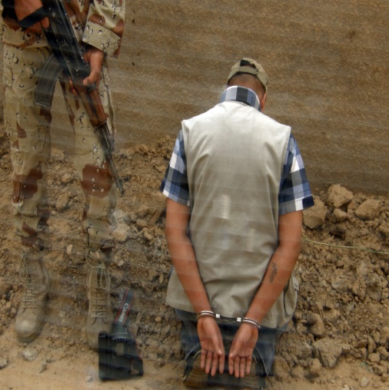
According to Transparency International, , based in Germany, Iraq ranked third among the most corrupt countries in the world in 2008, preceded only by Somalia and Myanmar.
On May 25, 2009 Prime Minister Nouri al-Maliki filed a lawsuit against “Kitabaat” website for featuring an article by Ali Hussein entitled “Director of Maliki's office provides state posts to his relatives.” The PM requested financial compensation amounting to one billion Iraqi dinars ( nearly one million U.S. dollars).

On June 25, 2009 Al-Nasiriyah municipality filed a lawsuit against Al-Nasiriyah News Network website for publishing reports on the poor municipal services provided to citizens. Al-Nasiriyah Municipality demanded the Network to pay two hundred million dinars as compensation.
On November 5, 2009 a lawsuit was filed against the Chairman of Anbar Journalists Syndicate and Chief Editor of “Al-Jazeera” weekly accusing him of slandering the Anbar Governor and Provincial Council by criticizing its poor services to citizens.

On November 8, 2009 the Iraqi Parliament referred a request from a number of MPs to the Parliamentary Legal Committee for decision. The request was to suee “Al-Mada” daily for publishing an article criticizing the Parliament’s recent performance and claiming that its members did not deserve their special privileges.

In a separate incident, the Parliament’s Speaker demanded to see a copy of a program aired on “Al-Hurrah Iraq” TV about the privileges given to MPs. The Speaker wished to see whether the program constituted an abuse of Parliament.
“Al-Mada” daily published an article by Wared Badr Salem, in which he too criticized the performance of Parliament over the past years, noting: “Iraqis are explicitly aware that whether Parliament exists or doesn’t, it is the only entity that symbolizes new political life, post-2003. The Iraqi Parliament was the artificial image of a fledgling and growing democracy; its existence is more illusion than reality.”
On December 17, 2009, the Editor-in-Chief of “al-Sada” (The Echo) newspaper Ayad al-Tamimi was detained for the whole day in Kut after a lawsuit was filed against him by MP Makaseb Hameed of the Wasit province, who accused him of slandering her. Tamimi was then released on a bail of 5 million dinars.
On February 6, 2010, Dahuk police arrested the Editor of “Javdeer” weekly newspaper Abdel Rahman Bamarni, and his colleague Hochenk Sheikh Mohammed for publishing a poem by the latter on mosques and domes. Clerics criticized the poem in their Friday sermons as an abuse of Islam. The two journalists were then arrested on charges of defamation and insulting the Islamic religion, and detained for three days in the Zarka prison in Dahuk based upon an order issued by the Dahuk Court and lawsuit filed by a group of local religious scholars. The two journalists were charged in accordance with Article 372 of the Iraqi Penal Code, and released on bail after three days. Had they been convicted, Article 372 would have imposed three years of imprisonment on the two journalists.
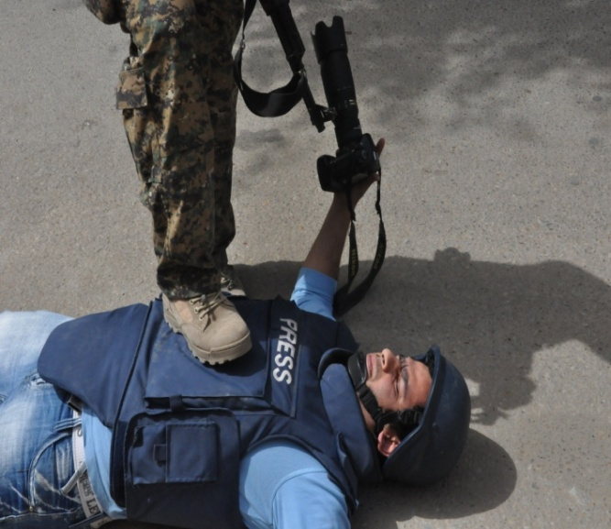
On February 16, 2010 a report on administrative corruption published by journalist Abdul Halim al-Rikabi made him subject to libel proceedings because it “could not be verifyied and did not have adequate credibility.” Journalists who publish reports uncoveringl administrative and financial issues are prosecuted often, despite the high credibility of their reports. Al-Rikabi said that the Deputy Chairman of the Political Prisoners Organization Jassim Mohammed Jaafar filed a lawsuit against him on August 8, 2009 after he had published documents uncovering administrative and financial corruption in the Organization.
On April 10, 2010 Dhi Qar Municipality filed a lawsuit against Al-Nasiriyah News Website for publishing a letter from a citizen complaining about poor services in the city.
On May 26, 2009 the London-based “The Guardian” newspaper said that the Iraqi Intelligence Service filed a lawsuit against it for publishing news from an undisclosed source that the Prime Minister “is moving towards increasingly autocratic rule”. The newspaper said that the lawsuit, which seeks compensation of one million dollars, was filed upon orders from the Office of the Prime Minister. The newspaper also said that the Iraqi government initially demanded the closure of the newspaper's office in Baghdad, but later dropped the demand.
The JFO believes that it is very important for press laws to be amended or redrafted in line with the Iraqi Constitution, which guarantees press freedom, and the International Covenant on Civil and Political Rights, which defends the right “to use, receive and convey information and ideas to others without regard to borders, or whether those ideas are conveyed via writing, or print or art or any other means”. Issuing a law that ensures the right to access information is essential to advancing and developing the press in Iraq.
According to reports, security and military forces, as well as government agencies have raided press establishments without court warrants or legal justification and shut down a number of them. It is clear that rule of law is absent given the acts committed by security and military forces in Baghdad and other Iraqi cities against publishing and news coverage, even though those rights are constitutionally guaranteed. All the cases of raid and closure of media institutions were done not through court order but rather on the basis of government orders only.

On May 3, 2010 a special security force stormed the headquarters of Radio Dimozee in Baghdad and tried to arrest a number of guards without a warrant. The Director of Radio Dimozee Ibrahim al-Saadi told JFO that the security force did not carry a court warrant authorizing them to enter the radio building or to confiscate any materials or equipment.
On February 17, 2010 the Dhi Qar Provincial Council shut down the al-Baghdadiya TV office in al-Nasiriyah. A source at al-Baghdadiya TV told JFO that the Council blocked his station from working in al-Nasiriyah for ‘promoting the dissolved Baath Party and focusing on the negatives without professionalism or impartiality’.
On February 5, 2010 the Chief Editor of “Al-Shahid” weekly Saad al-Awsi said that a security force stormed his newspaper office in central Baghdad and shut it down after confiscating computers and electronic files, and driving out his staff forcibly.
In July 2009, the Director of Radio Al-Nour in Baladruz Majid Mohammed told JFO that a security force, upon orders from city Mayor Mohammed Marouf, broke into the Radio station building without a court warrant, closed it, and expelled all staff.

Security and military agencies continue arbitrarily arresting and detaining journalists and writers who investigate and report on administrative and financial corruption in Iraq. Most of these arrests are carried out by Iraqi military personnel who are associated with military and security commanders. The fate of Chief Editor of “Al-Shahid” weekly Saad al-Awsi is still unknown after he was taken by military force from his home on April 15, 2010. With military forces in Baghdad denying detaining al-Awsi, JFO can only consider this to be a forced disappearance.
On February 28, 2010 security and military forces raided and cordoned off three publishing houses in Baghdad -- al-Maghreb, Al-Janoub and al-Kawthar -- confiscating a 16-page booklet entitled “Where has Iraq’s money gone?” which covered financial and administrative corruption in Iraq over the past four years. The security forces arrested 6 employees, transferred them to an unknown location, then blocked media from reaching the publishing houses for several days.

During the March 2010 national elections, “Al-Itijah” TV reporter Haroon Rashid was arrested by local police in the Olweya area of Baghdad on March 6 while covering the special balloting that was taking place there.
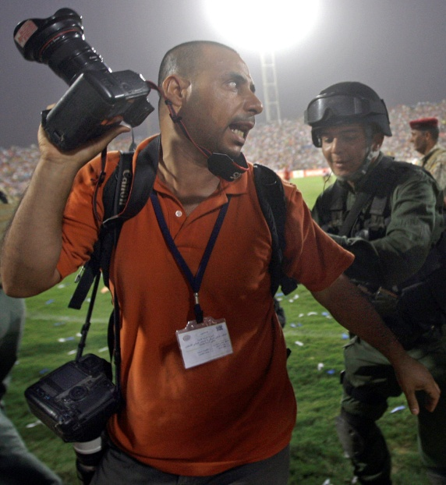
On the day of the general election (March 7) Iraqi military personnel belonging to the First Division of the Second Brigade held 9 reporters inside a military vehicle and confiscated their cameras when they tried to interview citizens in Fallujah who accused the army of failing to maintain security and prevent the launching of rocket-propelled grenades during the voting process.
On February 17, 2010 areporter of “Kurdistan” TV channel, Sattar al-Mansouri, was arrested and interrogated by Basra police while he was filming in public places.
On January 11, 2010 a police patrol in the al-Kifl area, south of Hillah, arrested the “Al-Ghadeer” TV team, including reporter Ahmed Shebr and cameraman Haider Sweig, while they were doing their work. Police held them for 6 hours without providing legal justification or even apologizing to them.
The Director of “al-Baghdadiya” TV in Baghdad Taleb al-Sadoun told JFOthat members of Baghdad Operations Command assaulted and detained his colleague Ali al-Khalidi on January 24, 2010 in the al-Kahirah district north of Baghdad.

On January 31, 2010 a military force detained 12 journalists in Maysan province. The JFO representative in the province said that a number of media teams, including al-Iraqiyah, al-Rasheed, Baghdadiya, Assalam and al-Itijah TV channels, travelled to one of the oil fields to cover the clearing of mines planted around the oil wells at one of the border points. He said that the Ministry of Interior’s Eleventh Brigade located in Maysan prevented reporters and photographers from covering the event and tried to confiscate their gear and cameras without justification, then detained the reporters and held them in Brigade headquarters.
On December 17, 2009 the editor of “Al-Sada” newspaper Iyad al-Tamimi was arrested in al-Kut for one day when MP Makaseb Hameed filed a lawsuit against him in Wasit province, accusing him of slander.
On January 5, 2010, journalist Mahmoud Arslan was detained by the Kurdistan Democratic Party (KDP). KDP official Halo Kurda said that Arslan was “under investigation” at the party's political bureau in Saladin resort.
On October 29, 2009 the Director of “al-Itijah” TV, Hamid Akaab, told the JFO that his TV announcer Sarmad Al-Bayati and cameraman Imad Khyoun were detained in al-Ghadeer area near al-Rusafa because they were not carrying a permit issued by Baghdad Operations Command authorizing them to work in Baghdad. Akaab said that the security officers told them that “upon instructions given by the Prime Minister, nobody is allowed to film unless he obtains permission daily, for every day of filming in the capital.”
On September 12, 2009 Reuters cameraman Ahmed Malik was arrested, beaten, verbally abused, and then his gear was confiscated by Iraqi military personnel.
On August 20, 2009 a security force arrested three photographers working for international news agencies while covering the funeral of terror blast victims in Baghdad. One of the photographers who was working the event near the forensic hospital said that the security force detained three of his colleagues --Thaer al-Sudani, a Reuters photographer, Reuters cameraman Haidar Kadhim Nour, and European Agency photographer Shehab Ahmed. The three were later released.
On July 7 2009 Al-Salam TV correspondent Ammar al-Alwani was detained in Ramadi,t Anbar province by the protection detail of the leader of the Iraqi Awakening Council Sheikh Ahmed Abu Risha when Prime Minister Nouri al-Maliki was visiting.
On June 10, 2009 the correspondent of Radio Al-Aahed, Jassim al-Kanani, was arrested by police for attempting to cover an explosion in the city of Al-Batha in the province of Dhi Qar.
Other methods used by the government to try to control the free flow of information and limit the knowledge of citizens is through censorship and control over the Internet in the country.
The Minister of Communications Farouk Abdul-Kader admitted on July 22, 2009 that a proposal was submitted to set controls and limitations on the use of the Internet in Iraq. He said: “The Prime Minister issued instructions to impose controls on publishing on the Internet because what is published is beyond control.” He added that “the directives were issued to set controls and restrictions to prevent any trends that may affect the morals of the country.”
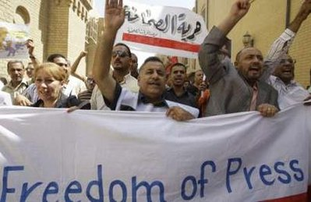
These measures violate Article 40 of the Iraqi Constitution which stipulates that “the freedom of communications and postal, telegraphic, telephonic, electronic and other means of correspondence may not be monitored, censored or disclosed”.
JFO views the justifications made by authorities, such as the protection of national security and ethical standards in society, as excuses to ban and censor the Internet, and restrict freedom of expression.
The Ministry of Communications and General Company for Internet Services have begun to license Internet cafes in Iraq under the pretext of organizing their work. In their website statement, the Ministry explained that “this procedure was taken due to the importance of organizing the work of Internet cafes” in Baghdad and other provinces.
JFO believes that governments that do not want people to speak freely, begin by preventing political discussions on the Internet, and they often require companies that offer Internet services to apply program controls.
International laws and treaties, however, ensure the protection of expression freedom and prevent the imposition of restrictions on them. They call for unblocking Internet websites in all regions of the world.
A media professor at Baghdad University, Hassan Kamel, says that the Iraqi government’s measures are “worrying and have serious implications”, and that this is what drives Iraqis to seek constitutional guarantees on information access information and genuine legal guarantees for freedom of expression.
Under the former regime, Iraq had imposed strict government control on the limited use of the Internet through the Ministry of Communications and Public Security, placing it under the supervision of senior security commanders.
Government authorities, in their war against media materials they claims incite sectarian violence, continue to impose new restrictions on the media. Critics counter by saying that such reins will bring back the era of strict control known under Saddam Hussein’s regime.
Just before the March 7 parliamentary elections, the Media and Communications Commission imposed new regulations. Among these of special concern to the critics, are the requirement for all media and journalists to obtain permits to work in Iraq from the Iraqi National Media and Communications Commission, presenting lists of staff names and equipment, and declaring they will not incite sectarianism or violence.
JFO studies show that these regulations are a clear and explicit attempt to control media, undermine its independence and permit the government to impose control over media programs.
Regulations do not define what “inciting sectarianism or violence” means. As such, these regulations can be used to silence media that publish the actual numbers of bombing victims, and other numbers that the government usually wants to minimize.
Former Iraqi President Saddam Hussein had imposed severe restrictions on the media through the Ministry of Information, but after his regime was toppled in 2003, newspapers and television and radio stations flourished in Iraq.
Officials say that the new regulations, set forth by the Iraqi National Media and Communications Commission, are designed to suppress media that incite sectarianism. But, from a legal point of view, it is not the task of the Iraqi National Media and Communications Commission to establish regulations for journalists. Foreign media agencies are already registered at the Iraqi Foreign Ministry, and the law provides that Iraqi printed media should organize itself.
JFO believes that these officials are trying to act like police officers, controlling the media rather than like a committee trying to organize its modus operandi.
Officials in the Iraqi National Media and Communications Commission say that journalists may not be able to maintain the confidentiality of their sources, a principle of the press applicable worldwide. They say journalists must disclose their sources in order to defend themselves when allegations are made against them for publishing incorrect news.
In its message to the Iraqi National Media and Communications Commission, Human Rights Watch called on the Iraqi government to freeze the applying of these regulations, and to reconsider them in order to be consistent with international media norms. Human Rights Watch recommended these regulations be reviewed and that detailed definitions be provided for each restrictive measure, in order to provide clear guidance to media organizations and to explain in detail their work responsibilities, while maintaining the government’s ability to ban or punish voices that incite violence overtly. The vague wording of regulations, such as prohibiting “inciting sectarianism”, falls short of international standards governing freedom of expression.
The Deputy Executive Director of Human Rights Watch for the Middle East and North Africa, Joe Stork, said that “These regulations on media broadcasting are a real step backwards on the path to media freedom in Iraq…These restrictions open the door to politically motivated discrimination with regard to the regulating and licensing of media organizations.”
Over the months leading up to the March 2010 elections, the government restricted freedom of expression in many ways. It tightened the noose on those who criticized officials, stopped granting permits to journalists, and sued media outlets that criticized officials. Police and security forces harassed, arrested and assaulted a large number of journalists.
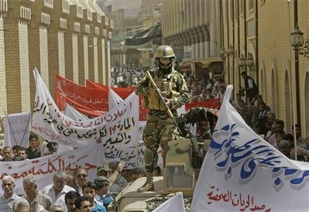
In its message, Human Rights Watch urged the Iraqi National Media and Communications Commission to ensure that penalties are commensurate with the volume and recurrence of violations committed. The regulations should also identify clear procedures to be followed by license requestors to enable them to challenge denial decisions. Joe Stork added: “It's not just that the regulations would give the Iraqi National Media and Communications Commission extensive powers to shut down media outlets due to minor or first time committed infractions, but they endanger the lives of Iraqi journalists…The Iraqi Media Commission must stop imposing these regulations until they are amended.”
Because these measures threaten and restrict freedom of opinion and expression, Iraqi journalists and their press freedom support lobby have taken counter-measures. For example, they staged a large protest demonstration on August 14, 2009 on al-Mutanabi Street in central Baghdad. JFO believes that the demonstration, which involved hundreds of journalists and intellectuals and called for freedom of expression and flow of information as well as the protection of acquired freedoms, succeeded in calling attention to the challenges facing journalism in Iraq. It also raised awareness on the need to pass new legislation and enact laws that guarantee the right to information access and respect for freedom of expression.
JFO, along with journalists and intellectuals in Iraq, stands firm against any attempt to undermine press freedom or freedom of expression. The above demonstration was within this context. JFO affirms it will not hesitate to take serious action against any infringement on the freedom of the press and expression as guaranteed under the Constitution.
The demonstration by JFO and activists in the field was in response to a series of challenges facing the press, media and cultural professions in the country. It addressed the risks imposed on journalists, intellectuals and media, who are abused by government agencies and political parties to deny them their vital role in building and continuing the democratic process that has been taking place in Iraq since 2003. These barriers to political and intellectual freedom prevent Iraq from becoming a model to be emulated by others in the field of freedom of expression, creativity, the arts and literature.
The demonstration came after a series of decisions and announcements planning to block the entry of publications into Iraq, to impose censorship, and to ban Internet sites under false pretense, It came because of the assaults of media teams during the last few years, a continuation of what the journalists were subjected to over the last six years, and subsequent attempts to muzzle them, restrict their freedoms through fear and intimidation tactics.
JFO commemorates World Press Freedom Day by reminding all of the issues and requirements facing the press in Iraq as mentioned in this annual report. We need to establish a basis for genuine partnership between active international institutions to ensure international solidarity in the field of press freedom, which is being violated in many ways in more than one place around the world. This occasion must not pass without noting that press freedom is a true guarantor of success in democracy, governance and partnership.
*

